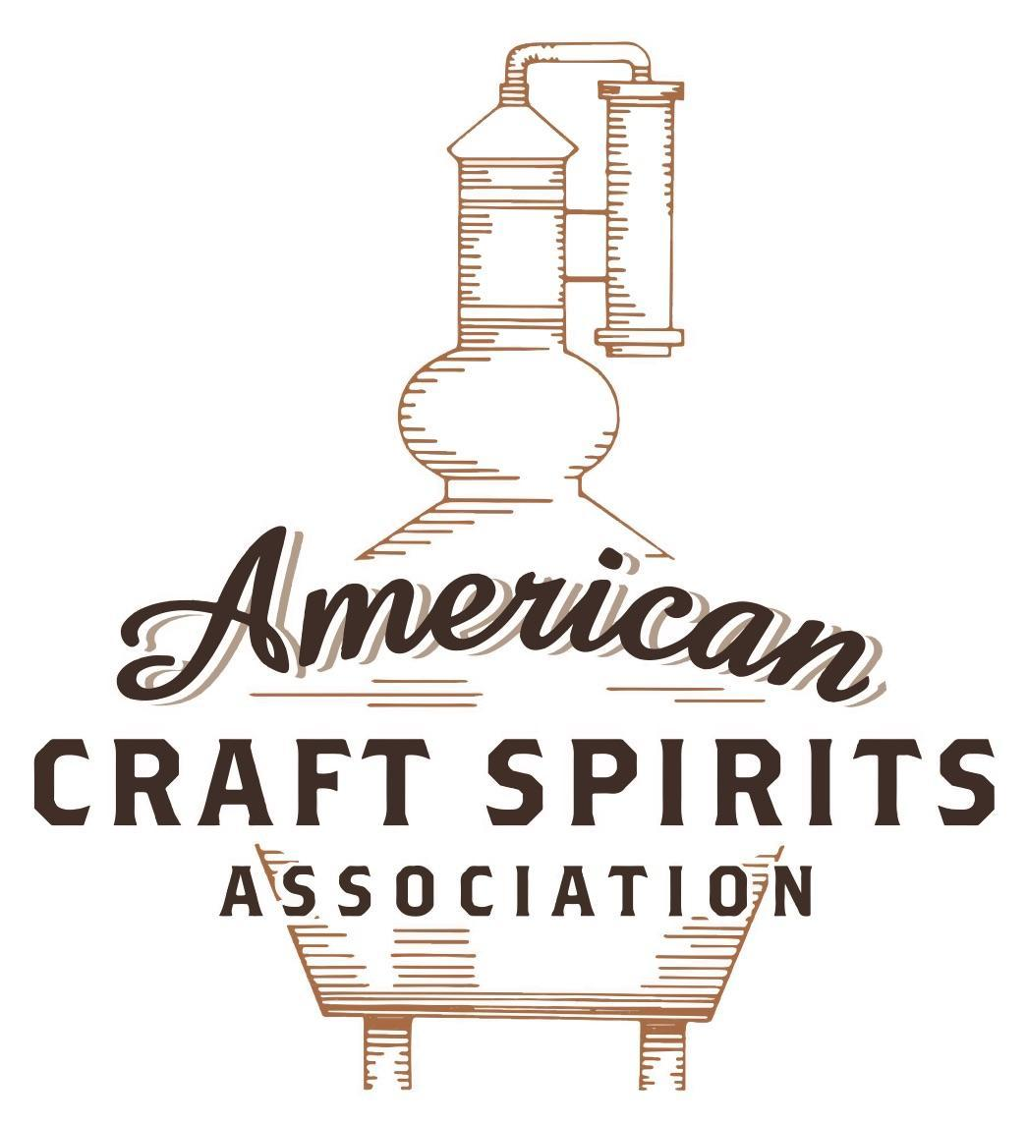
Spirits DtC Shipping Guide

This guide summarizes the direct-to-consumer shipping rules for distilleries in all 50 states and D.C. and also addresses the measures state governments have taken to ease delivery and shipping restrictions during the COVID-19 pandemic.

DtC Quick Guide Comparison

Out-of-State Distilleries  Can Ship Into State? |  |  |  | In-State Distilleries  Can Ship Within State?
State | Yes | No |  | State | Yes | No
AL |  | X |  | AL |  | X
AK | X |  |  | AK | X
AZ | X |  |  | AZ | X
AR |  | X |  | AR |  | X
CA |  | X* |  | CA |  | X*
CO |  | X |  | CO |  | X
CT |  | X* |  | CT |  | X
DE |  | X |  | DE |  | X
DC | X |  |  | DC | X
FL |  | X |  | FL |  | X
GA |  | X |  | GA |  | X
HI |  | X* |  | HI |  | ?*
ID |  | X |  | ID |  | X
IL |  | X* |  | IL |  | X*
IN |  | X |  | IN |  | X
IA |  | X* |  | IA |  | X*
KS |  | X |  | KS |  | X
KY | X |  |  | KY | X
LA |  | X |  | LA |  | X
ME |  | X* |  | ME |  | X*
MD |  | X |  | MD |  | X
MA |  | X |  | MA |  | X
MI |  | X |  | MI |  | X
MN |  | X |  | MN |  | X
MS |  | X |  | MS |  | X
MO |  | X |  | MO |  | X
MT |  | X |  | MT |  | X
NE | X |  |  | NE | X
NV |  | X* |  | NV |  | X
NH | X |  |  | NH |  | X*
NJ |  | X* |  | NJ |  | X*
NM |  | X |  | NM |  | X
NY |  | X* |  | NY |  | X*
NC |  | X |  | NC |  | X
ND | X |  |  | ND | X
OH |  | X |  | OH |  | X
OK |  | X |  | OK |  | X
OR |  | X |  | OR | X
PA |  | X* |  | PA |  | X
RI |  | X* |  | RI |  | X
SC |  | X |  | SC |  | X
SD |  | X |  | SD |  | X
TN |  | X |  | TN |  | X
TX |  | X |  | TX |  | X
UT |  | X |  | UT |  | X
VT |  | X |  | VT |  | X
VA |  | X |  | VA |  | X
WA |  | X* |  | WA | X
WV |  | X* |  | WV |  | X*

WI |  | X |  | WI |  | X
WY |  | X |  | WY |  | X

Notes:
*CA: If passed and signed into law, Senate Bill 620 would allow licensed distilled spirits producers in states other than California and licensed distilled spirits manufacturers or craft distillers in California who obtain distilled spirits direct shipper permits to ship directly to consumers in California
*CT: Consumers with appropriate permit may receive alcohol shipments
*HI: Consumers with appropriate permit may receive alcohol shipments; If passed and signed into law, Senate Bill 65 would allow licensed distilled spirits manufacturers in Hawaii and in states other than Hawaii who obtain direct shipper permits to ship directly to consumers in Hawaii
*IL: If passed and signed into law, Senate Bill 0532 would allow licensed distilled spirits producers in Illinois and in states other than Illinois who obtain distillery shippers’ licenses to ship directly to consumers in Illinois
*IA: If passed and signed into law, House File 639 would allow native distilled spirits manufacturers in Iowa and in states other than Iowa who obtain direct shipper permits to ship directly to consumers in Iowa and to consumers in states other than Iowa
*ME: If passed and signed into law, Legislative Document 1358 would allow distilleries outside of Maine with current manufacturer licenses and distilleries licensed in Maine who obtain spirits direct shipper licenses to ship directly to consumers in Maine
*NJ: (1) If passed and signed into law, Assembly Bill 3167 would allow a craft distillery licensees to ship no more than 9 liters of distilled spirits to a consumer in New Jersey; (2) If passed and signed into law, Senate Bill 3020 would allow craft distillery licensees in New Jersey or in states other than New Jersey to ship no more than 20 liters of distilled spirits to a consumer in New Jersey via common carrier
*NV: Licensed individuals can import one gallon per month of spirits for personal use and the out-of-state supplier must pay excise tax
*NH: If passed and signed into law, Senate Bill 125 would allow licensed liquor manufacturers who obtain direct to consumer shipping permits from the commission to ship directly to consumers in New Hampshire
*NY: Consumer may import up to 90L of liquor per year for personal use without a license; If passed and signed into law, Assembly Bill 3275 would allow licensed liquor manufacturers in states other than New York and licensed distillers and farm distillers in New York to ship no more than thirty-six cases (no more than nine liters per case) of liquor to consumers in New York
*PA: Consumer may place a special liquor order and distiller must ship to a PLCB-operated store
*RI: Distiller can only ship to customer if order was personally placed by customer at distiller's premises
*WA: If passed and signed into law, House Bill 1432 would allow licensed spirits manufacturers in states other than Washington to ship spirits to consumers in Washington
*WV: Distilleries, mini-distilleries, or micro-distilleries licensed in West Virginia or a state other than West Virginia who obtain private direct shipper licenses to ship to a consumer in West Virginia, however the shipments must be made to a retail liquor outlet

OHIO

Shipment Outbound – Yes (OH Rev. Code Ann. § 4303.04).
Shipment Inbound – No, OH only allows beer or wine to be shipped directly to consumers.
Shipment Intra-state – No, OH only allows beer or wine to be shipped directly to consumers. An A-3a permit holder may only sell on the premises either for on or off-premises consumption. Sales to a personal consumer may occur only by an in-person transaction at the permit premises (OH Rev. Code Ann. § 4303.041).
COVID-19 Measures – Only contract liquor agencies can sell bottles of spirituous liquor to a customer for carryout. However, a permit holder (including A-3a permit holders) or its employees can deliver drinks that are normally offered for on-premises consumption to consumers. A permit holder can work with a licensed H class permit holder to deliver the drinks-to-go on its behalf. A-3a permit holder can now sell a consumer up to three (3) liters of spirituous liquor per day from the permit premises. H.B. 669 makes permanent what is currently allowed under Ohio Liquor Control Commission Rule 80 regarding selling alcoholic drinks to-go that the qualified permit holder normally offers for on premises consumption.
Links:
https://www.com.ohio.gov/documents/DOLC-Rule80StakeholderMessageEdits_finalforwebsite.pdf https://www.com.ohio.gov/documents/DOLC_Bill669andHB160WhatyouneedtoknowFinal.pdf https://www.com.ohio.gov/documents/DOLC_LiquorPermitHolderFAQ's.pdf
Citations (shipment)
Ohio Revised Code Annotated
§ 4303.04 A-3 permit.
Permit A-3 may be issued to a manufacturer to manufacture alcohol and spirituous liquor and sell such products to the division of liquor control or to the holders of a like permit or to the holders of A-4 permits for blending or manufacturing purposes; to import alcohol into this state upon such terms as are prescribed by the division; to sell alcohol to manufacturers, hospitals, infirmaries, medical or educational institutions using it for medicinal, mechanical, chemical, or scientific purposes, and to holders of I permits; to import into this state spirituous liquor and wine for blending or other manufacturing purposes; and to export spirituous liquor from this state for sale outside the state.
Link: https://codes.ohio.gov/ohio-revised-code/section-4303.04

§ 4303.041 A-3a permit - sales restrictions.
(A) An A-3a permit may be issued to a distiller that manufactures less than one hundred thousand gallons of spirituous liquor per year. An A-3a permit holder may sell to a personal consumer, in sealed containers for consumption off the premises where manufactured, spirituous liquor that the permit holder manufactures, but sales to the personal consumer may occur only by an in-person transaction at the permit premises. The A-3a permit holder shall not ship, send, or use an H permit holder to deliver spirituous liquor to the personal consumer.
"Distiller" means a person in this state who mashes, ferments, distills, and ages spirituous liquor.
(B)(1) Except as otherwise provided in this section, no A-3a permit shall be issued unless the sale of spirituous liquor by the glass for consumption on the premises or by the package for consumption off the premises is authorized in the election precinct in which the A-3a permit is proposed to be located.
(2) Division (B)(1) of this section does not prohibit the issuance of an A-3a permit to an applicant for such a permit who has filed an application with the division of liquor control before March 22, 2012.
(C)(1) An A-3a permit holder may offer for sale tasting samples of spirituous liquor. The A-3a permit holder shall not serve more than four tasting samples of spirituous liquor per person per day. A tasting sample shall not exceed a quarter ounce. Tasting samples shall be only for the purpose of allowing a purchaser to determine, by tasting only, the quality and character of the spirituous liquor. The tasting samples shall be offered for sale in accordance with rules adopted by the division of liquor control.
(2) An A-3a permit holder shall sell not more than three liters of spirituous liquor per day from the permit premises to the same personal consumer.
An A-3a permit holder may sell spirituous liquor in sealed containers for consumption off the premises where manufactured as an independent contractor under agreement, by virtue of the permit, with the division of liquor control. The price at which the A-3a permit holder shall sell each spirituous liquor product to a personal consumer is to be determined by the division of liquor control. For an A-3a permit holder to purchase and then offer spirituous liquor for retail sale, the spirituous liquor need not first leave the physical possession of the A-3a permit holder to be so registered. The spirituous liquor that the A-3a permit holder buys from the division of liquor control shall be maintained in a separate area of the permit premises for sale to personal consumers. The A-3a permit holder shall sell such spirituous liquor in sealed containers for consumption off the premises where manufactured as an independent contractor by virtue of the permit issued by the division of liquor control, but the permit holder shall not be compensated as provided in division (A)(1) of section 4301.17 of the Revised Code. Each A-3a permit holder shall be subject to audit by the division of liquor control.
(D) The fee for the A-3a permit is two dollars per fifty-gallon barrel.
(E) The holder of an A-3a permit may also exercise the same privileges as the holder of an A-3 permit.
Link: https://codes.ohio.gov/ohio-revised-code/section-4303.041

The American Craft Spirits Association (ACSA) is working diligently to give our members and industry partners relevant, current updates on statutes and regulations impacting production, sale and distribution of spirits. With the declaration of the novel coronavirus (COVID-19) in early 2020, many states have issued temporary policy changes or longer-term modernization of alcohol beverage laws. State statutes, regulations created by the state alcohol regulatory authority, as well as any other relevant guidance provided by such authorities (such as advisories, opinions, bulletins, etc.) were reviewed in creation of this document. No city or county ordinances were reviewed. Distillers should be aware that even in states where direct shipping is permissible, always remember to avoid shipping to dry counties. Please consult with your state guild or alcohol beverage authority for the most up-to-date information. This content is intended for educational and informational purposes only. ACSA's pro bono law firm of Malkin Law P.A. provided the core content found in this comprehensive overview of the spirits distribution after COVID-19. It was completed in August 2021 and will be updated regularly. If you have updates you would like to provide, please send to legislation@americancraftspirits.org or directly to the law firm at: ryan@malkin.law / malkin.law. Thank you.

